Belford Community Cinema presents:
Britain on Film: PROTEST!
Stories on Screen from the National Archives
UPSTAIRS at Bell View, 33 West Street, Belford NE70 7QB
Wednesday 15th January 2020
Doors 6.30pm/7pm start. Running time: 77 mins. £4 on the Door.

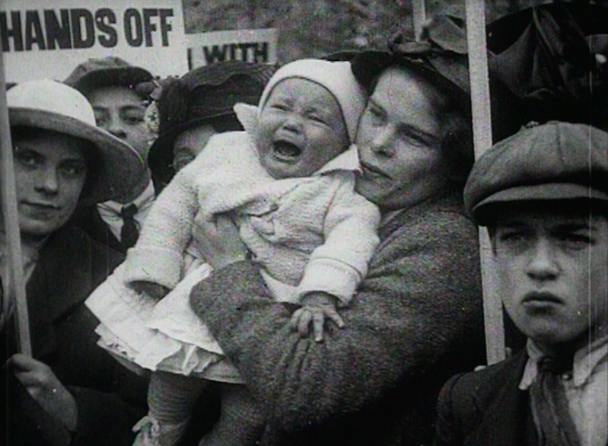

Sourced from the national archives and newly digitised PROTEST! Is an archive programme of hidden histories, which explores the dynamic history of public activism in the UK from 1910 to 1986.

From a 1910 suffragette demonstration to striking coal miners in the Rhondda Valley, from female CND protesters spanning the Tamar Bridge to the defeat of fascists at London’s Cable Street, this is an absorbing and illuminating collection. It looks at public protests both large and small, and for causes both regional and national, and by participants fighting for suffrage and democracy, against exploitation and inequality, for fair wages and worker’s rights, and for public safety, freedom and community, often in the face of war and oppression. A must-see for all social historians!

